STHS presents: Old Carversville Road

Join us for a walk to enjoy the cicadas and learn a little history of this beloved road

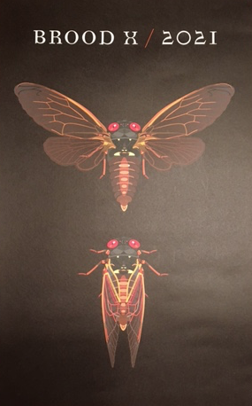

The Cicadas are re-emerging after 17 years! We feel as if we’re finally emerging as well. Join us on Sunday, June13th, 10am at Tinsman Bros. Lumberyard, 6632 Old Carversville Road, Lumberville, PA 18933
Wear comfortable shoes and bug spray for this 2 mile stroll.

This event is free
Door prize poster compliments of Friends of the Delaware Canal and Magicicada Design

